A000-ME-Eye Idol-Entire-rc

Case no.: 3

Ancient Nagar (modern Tell Brak) is one of the largest mound cities or tells in northeastern Syria with an extent of 43 hectares and a height of 45 meters. Its ancient toponym was Nagar, which we know from third millennium BCE cuneiform texts from Nagar and from Ebla, a 60 hectare trading partner some 280 km. to the west that was the repository of some 17,000 clay cuneiform tablets. The significance of third millennium Nagar is two-fold. Firstly, it was strategically located in the relatively dry southern margin of the Khabur plains from which vantage point it acted as a control point over an important well-watered agricultural zone. Secondly, it served as an entry point from the southeast, both the nearby plains and the more distant southern Mesopotamian cities such as Uruk, Ur and Lagash (Akkermans and Schwartz 2003: 185).

In the larger history of the area, the first complex, urban societies of the ancient Near Eat made their appearance in the period ca. 4000-3100 BCE, the Uruk period . Prior to this (the Ubaid period ) small centers were organized around a temple , but with the advent of Uruk an organizational hierarchy emerges with giant cities of 200 hectares (Uruk, Ur and Lagash ) controlling networks of small towns and villages. From the point of view of iconography there emerged specialized scribes, artisans, craftsmen, and architects who could incorporate symbolic decorations on everything from buildings to statues and figurines to sealed documents. Initially, writing with reed styli in cuneiform on clay tablets was mainly if not exclusively to keep records. Stone cylinder seals emerged for identifying sensitive materials. They were engraved with mythological and cultural symbols that were impressed on clay with the purpose of identifying the owner of the sealed property whether it be goods or entranceways to rooms and their contents.

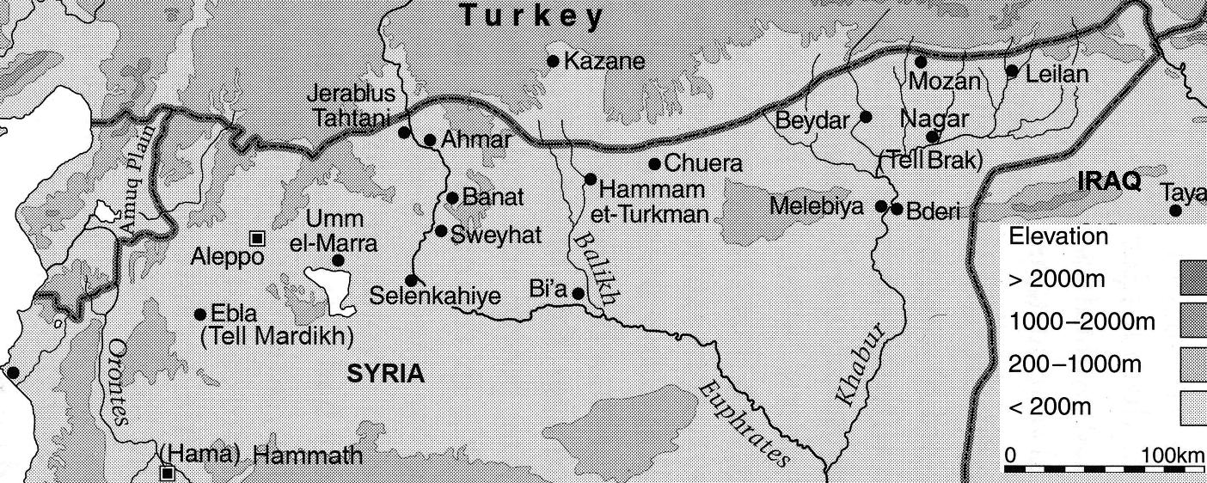 Fig. 1. Location of ancient Nagar (modern Tell Brak) in northeastern Syria and related Third Millennium sites including ancient Ebla (modern Tell Mardikh), a trading partner of Nagar. After Akkermans and Schwartz 2003: Fig. 8.1.

Nagar was remote from southern Mesopotamia from the sixth to the fourth millennium BCE. However, when Uruk began to expand after 3100 BCE Nagar was drawn into its orbit. For instance, it was during the Jemdet Nasr period (ca. 3100–2900 BCE) that Nagar became one of the most important cities in northern Mesopotamia.

Uruk's elite hierarchy and the institutions they controlled had a distinctive spiritual and mythic iconography associated with them. For instance, Uruk's Eanna district was the sacred precinct of the city's patron goddess Inanna. This spiritual iconographic imagery acted as a consolidating force for those who were within Uruk's orbit of influence.

Perhaps it was this stimulus that provoked the inhabitants of Nagar during the Jemdet Nasr period to develop their own distinctive cultic iconography that would provide a consolidating influence for Nagar's people to distinguish their spirituality from their more powerful neighbors to the south. If this were the impetus, then the knowledge of Uruk's patron goddess Inanna would have been a major challenge to oppose with an equally powerful goddess. During this period a unique cult did emerge in Nagar which was distinguished by unique, miniature figurines with pronounced circular "eye"-like motifs. During the Jemdet Nasr period, a monumental building was constructed in which were found hundreds of these miniature figurines. Its excavator in the 1930's and 1940's, Max Mallowan (whose wife was Agatha Christie), called this structure the "Eye Temple," but this epithet was presumptive since the purpose and meaning of the figurines was conjectural (Mallowan 1947).

The figurines were carved from calcite, alabaster and quartzite as well as being molded from clay. Their exact mode of usage and meaning is unknown but appears to have been associated with cultic activities by virtual of the location where they have been found. Their forms are of two main types, both of which Max Mallowan named "eye-idols" (Mallowan 1947).

**The First Type of "Eye Figurine": a flat, oblong, body**

The first type consists of a flat, oblong, body, tapering towards the top. There is no base for the figurine to stand upright, so that one hypothesis is that they were made to lay flat, but they just as easily could have been set in sand to stand upright. Their distinguishing feature is a pair of obliquely set eye-like circular or diamond-shaped carved motifs. There are no perforations that make holes through the material.

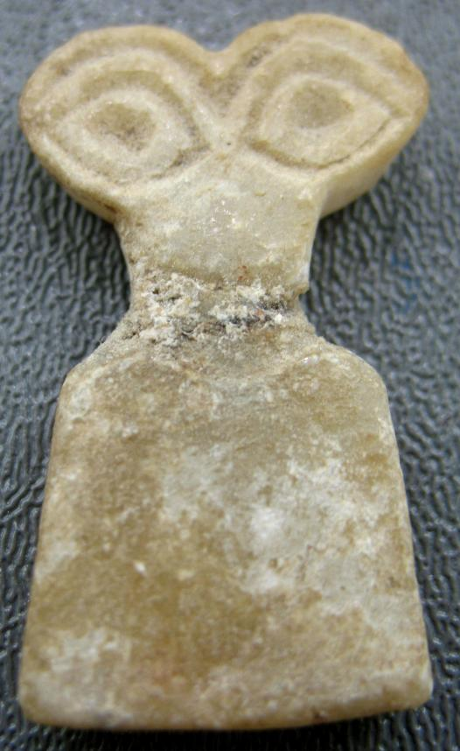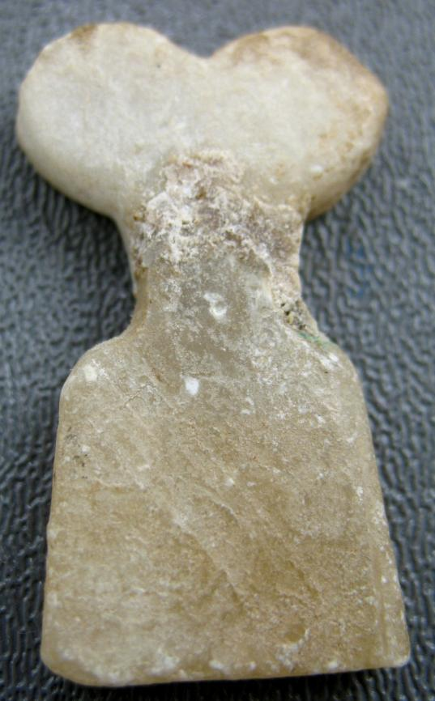

Fig. 2. Eye-Idol (3500-3300 BCE) from the Temple of the Eyes, Tell Brak, alabaster (gypsum), with repair at the neck. H. 1.5". (3.8 cm), Provenance: Atlantika Collection.

The first type has several sub-designs. For instance, one has four-"eyes" figurines in which a smaller figure is placed on the front of the body of a larger specimen as if to suggest a mother and child.

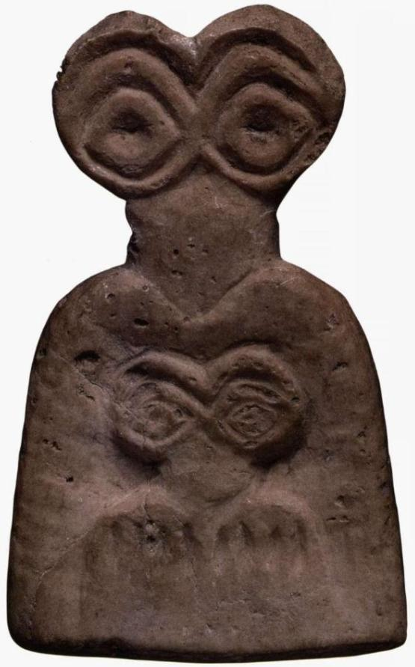

Fig. 3. Eye-Idol (3500-3300 BCE) from the Temple of the Eyes, Tell Brak, alabaster (gypsum), 3.5 cm. From http://www.skydive.ru/uploads/posts/2012-07/thumbs/1343107948_muzeum-

233.jpg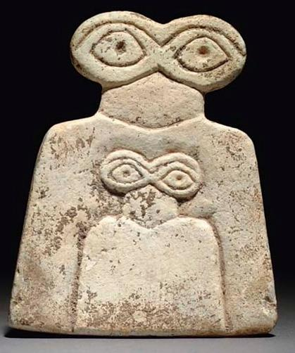

A variation on this lateral design is a vertical placement of the eye motifs:

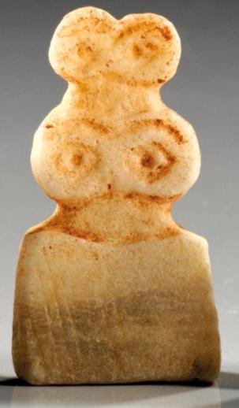

Eye-Idol (3500-3300 BCE) from the Temple of the Eyes, Tell Brak, alabaster (gypsum), 3.8 cm. Provenance: G. Hirsch, Auction 286, 5 - 6 February 2013

Other examples have four plus six eyes, which suggest parents and three children.

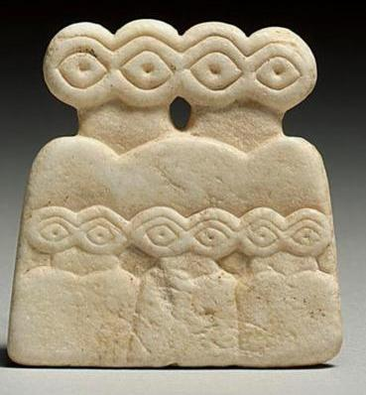

Fig. 6. Eye-Idol (3500-3300 BCE) from the Temple of the Eyes, Tell Brak, alabaster (gypsum), 1 7/8 in. 4.7 cm., [www.baghdadmuseum.org](http://www.baghdadmuseum.org/wmcd_index.htm).

Another design variation is the addition of a conical headdress denoting a sign of divinity. This is seen on god figures beginning in the early third millennium BCE.

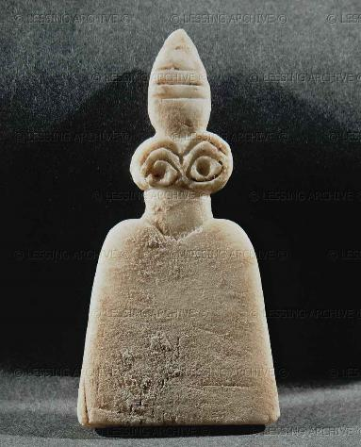

###### Eye-Idol (3500-3300 BCE) from the Temple of the Eyes, Tell Brak, **alabaster (gypsum),** height 8.1 cm. Provenance: National Museum, Aleppo, Syria. This thin plaque is in the form a figure, engraved on one side, with a short neck off-set from the body by a V, with two large eyes and a brow surmounted by a striated cone.

This striated cone headdress design was also doubled as in the non-**striated cone** headdress examples:

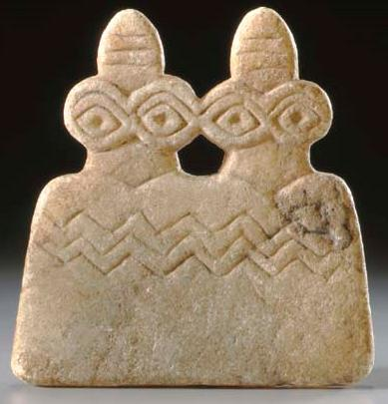

Eye-Idol (3500-3300 BCE), Tell Brak region, marble, 2 7/8 in. (7.3 cm.) high. Provenance: European Private Collection, 1980. Christie's New York, Rockefeller Plaza , Sale [1679](http://www.christies.com/LotFinder/searchresults.aspx?action=search&intSaleID=20147) , 16 June 2006, Price Realized $6,000.

This thin plaque is in the form of two conjoined figures, engraved on one side, each with a short neck off-set from the body by a V, three zigzags across their bodies, each with two large eyes and a single brow; each figure is surmounted by a striated cone.

That these eye idols are anthropomorphic is attested to by the Anatolian examples that have additonal anthropomorphic attributes and are dated to the same time-horizon:

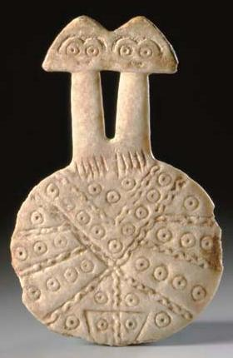

Anatolian marble two-headed idol, ca. 3rd millennium BCE, ¾ in. (12.1 cm.) high. Provenance: with Frederick Schultz Ancient Art, New York, 1994 (Mesopotamia: In the First Days, no. 19). Christie's, New York, Rockefeller Plaza, Sale [1679](http://www.christies.com/LotFinder/searchresults.aspx?action=search&intSaleID=20147)  16 June 2006. Price Realized[,](http://www.christies.com/MyChristies/my_settings_currency.aspx) $57,600

This disk-shaped body was embellished on one side with rows of dotted circles divided by undulating ribbon, forming a broad V at the top with radiating sections below, the top of an inverted triangle at the lower end, indicating the pudendum, with vertical lines at the base of the long necks and surmounted by two joined triangular heads, each with circular eyes under brows merging with a wide nose.

It is also clear that this embellished figurine evolved from a much painer example as can be seen in the following specimens:

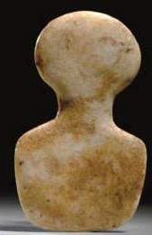

Anatolian marble idol ca 2700-2100 BCE, 2 11/16 in. (6.8 cm.) high. Provenance: European Private Collection, 1984. Christie's, New York, Rockefeller Plaza, Sale [1679](http://www.christies.com/LotFinder/searchresults.aspx?action=search&intSaleID=20147)  16 June 2006.  
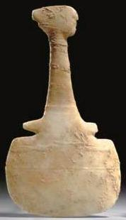

Anatolian marble idol ca 2700-2100 BCE, Kusura-Beycesultan variety, 6 in. (15.2 cm.) long  
Provenance: European Private Collection, 1989; Christie's, New York, Rockefeller Plaza, Sale [1679](http://www.christies.com/LotFinder/searchresults.aspx?action=search&intSaleID=20147) 16 June 2006, price realized $3,600 .

This variety features a pouch-like body with arm stumps, a long tapering neck and a disk-shaped head with a lateral projection on one side, a notch on the other

The conical headdress was a general indication of a divine status, but its use as a symbol of a particular major deity was never consistent. The Kassite kudurrus contains an inscription that names this symbol as that of the supreme God Anu (An). The iconography of the horned cap of divinity may be  linked to the Bull of heaven, the destroyer of worlds (a mythological Titan, given to Ishtar- Inana by her father the great god Anu-An). This can be seen in the limestone figurine of a bull below, Fig.

**The Second Type of "Eye Figurine": Perforated Eyes and Ovoid Base**

The second type has a ovoid base and a parabolic body with a flat base that makes a stand for the figurine to be set upright. The second type of the "Eye Figurine" was first excavated by Walter Andrae. This type has circular, eye-like rings (Andrae 1933: 30-32) with perforated holes that are set on top of a bell-like base usually without a "neck" Andrae hypothesized that the two perforated rings are the symbol of the goddess Innin (Andrae 1933: 36, 39). This type of figurine is rarer that the first type and has been claimed to be the older of the two. Both types come from roughly the same area in northeastern Syria. Andrae named them "House Symbols" because mythic symbols of the deity were often placed on top of houses in the ancient Near East. Andrae reasoned that the eye-like ring motif was the symbol of a deity that was placed on top of a mud-brick house. He felt that this interpretation was justified because he had found a steatite figurine of the second type placed on top of what appeared to be a mud-brick house complete with a reed-mat door (Andrae 1933: 33, pl. 45, a-b) and another example has recently been sold at auction (Fig. ).

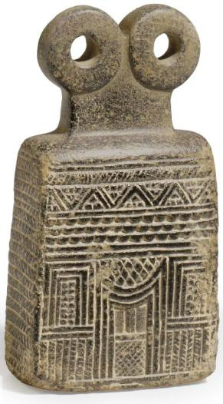

Spectacle Eye-Idol from Syria, ca. 3000-2500 BCE, 5 7/8 in. (14.9 cm.) high. Provenance: Elie Borowski, Basel, 1965, sold 9 June 2011, Christie's New York, Rockefeller Plaza, Sale [2450](http://www.christies.com/LotFinder/searchresults.aspx?action=search&intSaleID=23019) , price realized $40,000.

The rectangular architectonic base of Fig. has curving shoulders, sculpted on all four sides with a tiered facade, composed of several friezes including hatching, beading, zigzag, and crosshatching, centered by a doorway on each long side with a concave upper surface, the disk "eyes" above the waisted rectangular neck. In fact, reed-mat doors are still used in mud-brick houses in the area extending from northern Iraq to present day Konya plain, Turkey, where Çatal Hüyük, a Neolithic site of mud-brick structures dating to ca. 6500-5500 BCE is located (pers. observation).

A variation of the second type is one that incorporates a cone as a base.

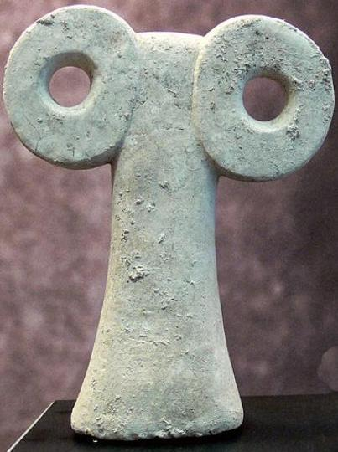

Plain Spectacle Eye-Idol, calcite, height 19.3 cm., from Tepe Gaura, northern Iraq, four kilometers east of Khorsabad. ca. 3000-2500 BCE Museum zu Allerheiligen, Schaffhausen, Switzerland.

This iconography is plain, without any embellishments and appears to be a large specimen that was designed to be especially powerful.

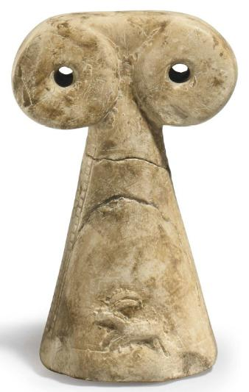

Iconic Spectacle Eye-Idol from Syria, ca. 3000-2500 BCE, 5 7/8 in. (14.8 cm.) high. Provenance: Irvin Gilbert Kipsby, New York, 1981; Christie's New York, Rockefeller Plaza, Sale [2450](http://www.christies.com/LotFinder/searchresults.aspx?action=search&intSaleID=23019) , 9 June 2011, price realized $10,625.

This iconography is apparently transitional since it incorporates two iconic images of an ibex and a panther in relief along the body, flanked by vertical hatched bands along the sides.  
.

**The Meanings of the "Eye-Idol" Figurines**

Max Mallowan acknowledged that the meaning and significance of these figurines is conjectural. Therefore, he suggested four interrelated interpretations: 1) that the figurine's eyes were a protective or apotropaic symbol. He further to suggest that this symbol also may be associated with medical treatment of those with eye diseases (as was a well-known Roman practice of offering replica body parts in the cult of Asclepius the healer.); 2) that the figurines were amulets that associated the worshipper's image of the deity with that of the deity itself, thereby deriving the divine power by sympathetic magic; 3) that the eye-like motifs were the abstract symbol or aniconic image of a deity to whom they were dedicated in a votive offering; 4) that the eye-like motifs simply represented a deity.

The geo-politico-religious significance of these "eye figurines" is strengthened by the fact that the Nagar "Eye-Temple" resembles the Uruk temple of Inanna and several other southern Mesopotamian cognates. These temples "were committed to an unbroken tradition of Mother-goddess worship" in the person of the goddess Innin according to Mallowan. Moreover, the votive offerings at Uruk and Nagar were similar in iconography: the outer walls of the "Eye Temple" at Nagar were decorated with rosettes that also appear at Uruk and are emblems associated with the Inanna. Therefore, Mallowan reasoned that it is logical to suppose that similar motifs in similar architectural settings were demonstrative of a cult devoted a similar deity (Mallowan 1947).

Both Andrae's or Mallowan's hypotheses suggest that these figurines are related to a similar aspect of worship of the divine, however that is defined. Until we have cuneiform documents specifying aspects of their use in the temples so far discovered we shall have to remain content that the figurines represent a five-thousand year-old Mesopotamian spirituality that had its adherents in the thousands.

Other eye talismans have been found depicting models of eyes cut into semi-precious stones, these are known to date from Sumerian to the Neo-Assyrian periods. These artifacts are known as the ‘Eyes of Ningal’. The goddess Ningal was the wife of the god Nanna, also known as Sin and she was the mother of the sun god Shamash, who was worshiped at Ur. Her cult developed independently in Syria as early as the second millennium BCE, where her name was changed to Nikkal. This form of her name was also used in Babylonia.

Other statuettes and figurines have been found, which depict worshipers, rather than Gods, looking into the heavens with wide staring eyes, at various other temple sites scattered across the Mesopotamian planes, throughout most periods. Although there is no evidence from any excavated materials that eye idols were made of perishable materials such as tamarisk wood, dough, bitumen or wax, this may have been done if the eye idols were votive offerings. However this practice is documented in cylinder seals and ritual inscriptions for other votive objects at other temple sites.

### The Sumerians in southern Mesopotamia developed a logophonetic language in the mid fourth millennium BCE in which the sign of the word signified its meaning and its sound. Sumerian is a language isolate unrelated to any other language including Semitic. During the third millennium BCE the Akkadians in northern Mesopotamia developed the earliest Semitic language. In their contacts with the Sumerians in the south they adopted the use of cuneiform while engaging in intimate linguistic and cultural contacts. Consequently, the Sumerian and Akkadian concepts of deity became closely allied. For instance, the Sumerian concept of deity or powers of a deity developed from the rosette to the cuneiform "DINGIR." In Akkadian this concept of deity became , ***’****il* and ***’****ilu,* which is cognate withthe Northwest Semitic ***’ēl* and Arabic *’Ilāh*.** [According to modern convention, small **capitals identify a Sumerian cuneiform sign, while the Akkadian phonemic value of a sign in a given context is given in lower case** italics. For purposes of clarification in this text all Akkadian words will also be underlined to distinguish their phonemic values from those of other languages.] In Sumerian, "DINGIR" could have the force of an unspoken determinant to specify the meaning of the following word. Thus, Sumerian is conventionally transliterated as a superscript "D" as in DInanna. Akkadian is transliterated acrophonically in which the components of the word stand for its sound as in the Semitic ***’****il* (***’el*) and not for its logographic meaning (Labat and Malbran-Labat 1988: 48-49).**

### In translating these two words for deity (DINGIR and ***’****il*, ***’****ilu*), it is important to clarify that they do not have the meaning of the Judeo-Christian "God" as "**The One object of supreme adoration; the Creator and Ruler of the Universe"** (OED 1989, meaning II). Rather, they are closer to the Indo-European concept of "god" as defined by the Oxford English Dictionary as "An image or other artificial or natural object (as a pillar, a tree, a brute animal) which is worshipped, either as the symbol of an unseen divinity, as supposed to be animated by his indwelling presence, or as itself possessing some kind of divine consciousness and supernatural powers; an idol" (OED 2012, meaning 2). The Indo-European etymology derives "deity" from the Latin *"dea"* ("goddess") and *"deus"* ("god"), which derive from the Sanskrit "*deva*" ("god") and "*devi*" ("goddess").

Now we are in a position to explore the concept of a certain kind of DINGIR and *’il*, *’ilu*, one made of stone. An Old Babylonian juridical text from the Larsa area indicated that "the weapon of the stone deity" witnessed an oath: giš TUKUL *ša dAb-nu-um* (Charpin 1980:243, Nos 58a:23-24). The significant part of this text is that the deity is made of stone and that it witnessed an oath. In other words it was animate. The following deity indicated by its horned headdress and anthropomorphioc visage is also made of stone and probably was an apotropaic deity protecting the entrance to the Tell Brak temple it guarded. Furthermore, the iconography of the rhombic-shaped eyes are very similar to those of the so-called "eye-idols."

In Sumerian the concept of seeing with an open eye suggests a metaphoric sense of prescience since

Sumerian compound verbs usually involve a noun immediately before the verb, forming a lexical or idiomatic unit

igi...du8, lit. "eye-open" = "see"

Furthermore, the eye is important as a device of introspection as well as for physical vision:

ug6, u6[IGI.É]: n., amazement; gaze, glance (['EYE' + 'HOUSE']).

v., to look at; to stare at, gaze; to be impressed.

adj., astonishing. (Hallaoran 2012)

This, when coupled with the Sumerian concept of a seemigly inanimate object like a stone is itself astonishing for it links stone with priest:

šuba(2/3): n., a precious stone - agate (?); a priest (cf., sipad).

which in turn links to the nomadic concept of a watchful shepherd:

sipad, sibad, sipa; šuba; sub2,3: n., shepherd; keeper [SIPA archaic frequency: 4].

v., to pasture, tend (si, 'to keep in order', + bad, 'to let out', or pàd, 'to find').

Therefore we have in a limestone figure the image of a watchful, faithful shepherd as he is embodied in an anthropomorphic bull dating to ca. 2200 BCE.

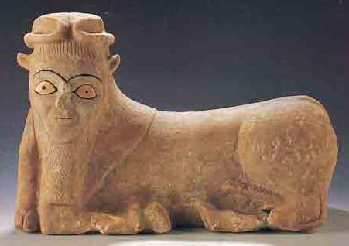

Anthropomorphic apotropaic limestone bull with, ivory eyes and horns of divinity, ca. 2200 BCE 17 in. long, from Tell Brak, from the Syrian Ministry of Culture (after “WorldWide.” *Biblical Archaeology Review*, May/Jun 2000, 72. http://members.bib-arch.org/publication.asp?PubID=BSBA&Volume=26&Issue=3&ArticleID=9 (accessed 3/7/2013)

This association of iconic stone figurines with a priestly and divine function is further suggested by a series of twelve human effigy statues with eye images that are similar to those of the "eye-idols" from Tell Brak were excavated by Henri Frankfort at Tell Asmar in Iraq's Diyala Plain in the 1930's. Tell Asmar was occupied in the Early Dynastic period (3000-2350 BCE) following Tell Brak. If the two sites are related, then the transition from the aniconic Tell Brak "eye-idols" to the Tell Asmar "eye figurines" is provocative for it would indicate that there was a progression from the aniconic to the iconic in the depiction of believers and their deities. Tell Asmar continued to flourish and probably became the provincial capital of Eshnunna during the Ur and Babylonia period (2065-1762 BC). The figurines were stacked in several layers within an 85x50 cm hole 1.25 meters (about 4 feet) below the floor of the structure known as the Square Temple.

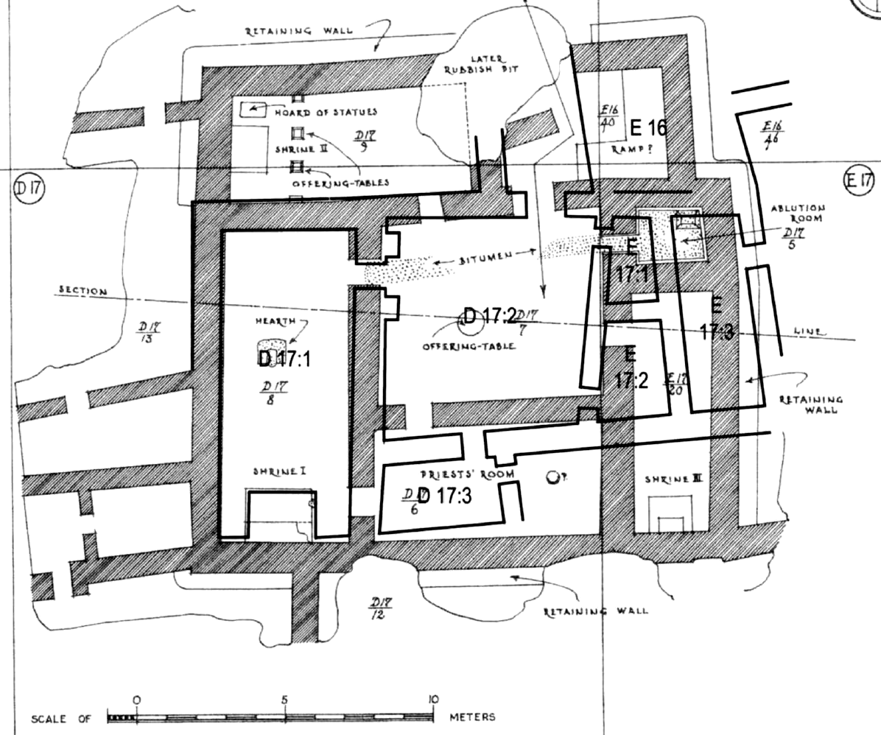

Plan of the Square Temple in diagonal lines with the earlier predecessor in solid lines (adapted from Delougaz and Lloyd 1942, pl. 22).

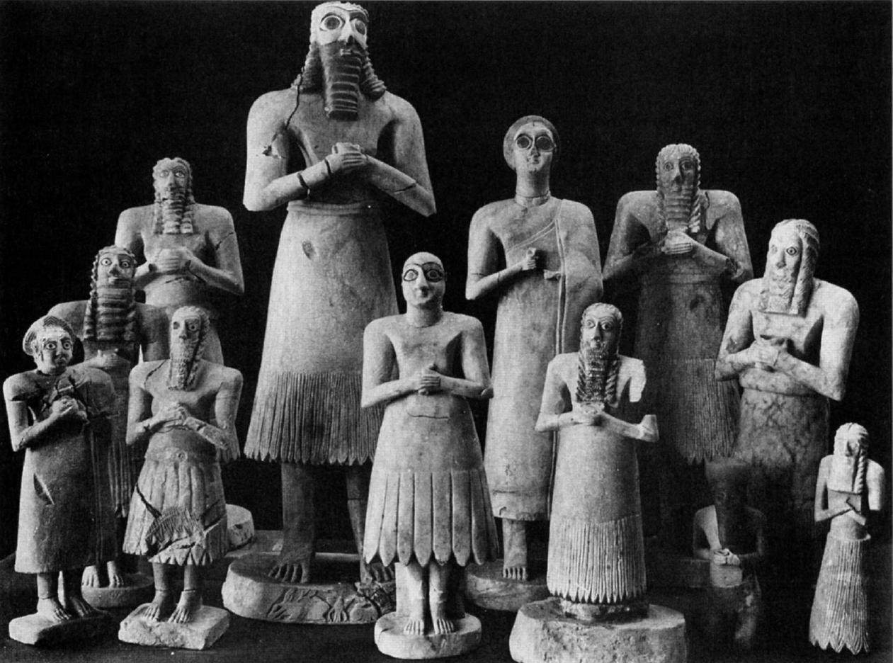

Figurines from Abu Temple at Tell Asmar (after Frankfort 1935, fig. 63).

The statues average about 42 centimeters in height. They are of men and women with large staring eyes, upturned faces, and clasped hands, dressed in the skirts of the [Early Dynastic period of Mesopotamia](http://archaeology.about.com/od/mterms/qt/mesopotamia.htm). They are believed to represent gods and goddesses and their worshipers. The largest male figure is thought to represent the god Abu, based on symbols carved into the base.

The Asmar statues were modeled from processed gypsum (calcium sulphate). The ancient technique involves firing gypsum at about 300 degrees Fahrenheit until it becomes a fine white powder (called plaster of Paris). The powder is then mixed with water and then modeled and/or sculpted.

The exact location of the hoard with regard to the temples is somewhat in question. Most sources refer to it as either below the Abu or Square temples at Asmar. Evans (cited below) believes the hoard, discovered well beneath the floors of the Square Temple, predates both temples.

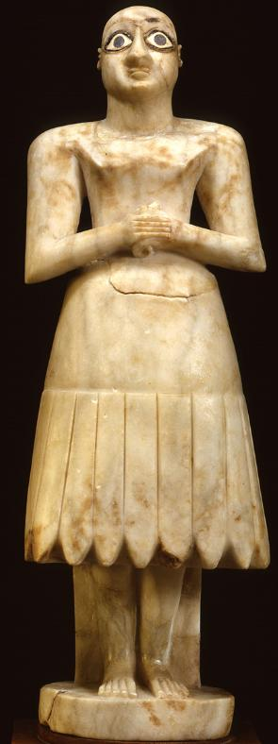

Bald Mesopotamian worshipper figure, Gypsum inlaid with shell and black limestone, 40 cm (1 ft 4 in), 2900-2600 BCE, Abu Temple, Tell Asmar, Iraq. Location: Oriental Institute Museum, Chicago, Illinois, Oriental Institute Museum A12333. From http://teachmiddleeast.lib.uchicago.edu.

This figurine of a bald male worshipper standing reverently before his god was found in the same location as the bearded male divinity below. The significance of being bald indicates a sense of austerity, while long hair and beard indicates its holiness. Statuettes were placed as votive objects in temples to stand in perpetual prayer in place of their owners.

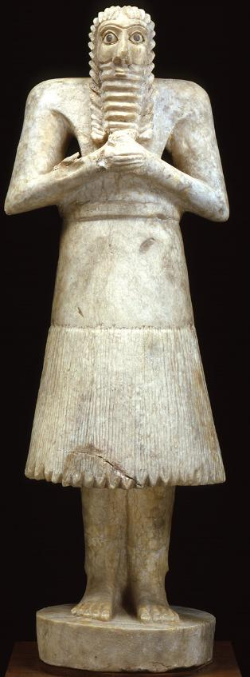

Bearded Mesopotamian deity figure, gypsum inlaid with shell and black limestone, 55 cm (1 ft 9.6 in), 2900-2600 BCE, Tell Asmar, Khafajah, Iraq, Oriental Institute Museum, Chicago, Illinois, Oriental Institute Museum A12331. From http://teachmiddleeast.lib.uchicago.edu.

SHAPE \* MERGEFORMAT 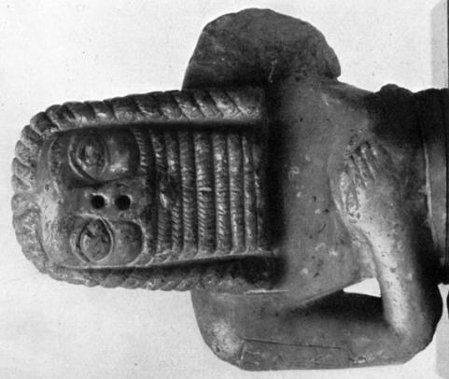

Bearded male figure, reddish calcite, 5 3/4 in high, from the environs of Babylonia before October 1868 (after Gadd 1934, plate XI,1).

This bearded male figure may be another deity. It was found in the environs of Babylonia when it was featured in an article in the *Revue archéologique* of October 1868 (Gadd 1934: 42).

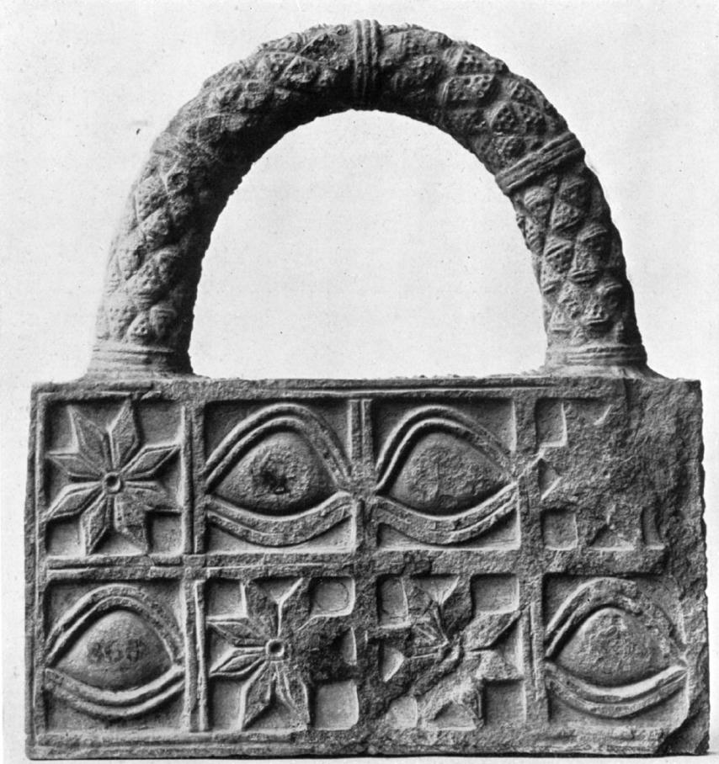

Model of a votive basket (?) of grey slate or schist , 7 5/8 in wide, 8 1/8in. high, from Ur excavations by J. E. Taylor, 1853-1854, object no. 91700 (after Gadd 1934, Plate 12, 1).

This sculpture which appears to be a model of a votive basket would be in keeping with the practice of providing food and libations to deities in their shrines. This figure is carved with the iconographies of both the eye-idol and the eight-pointed rosette  which symbolizes  **DINGIR,** a deity, an emblem of Ishtar or Inana.

Therefore, we apparently have a depiction of the watchful eye of both the deity and the worshipper that began with the practice in northern Mesopotamia in the Jemdet Nasr period (ca. 3100–2900 BCE) and persisted to the late third millennium BCE when the earlier quasi-aniconic "eye-idol" became fused to the anthropomorphic images of the watchful priest and the deity.

**References:**

Akkermans, Peter M. M. G. and Schwartz, Glenn M. 2003*. The archaeology of Syria from complex hunter-gatherers to early urban societies (c. 16,000-300 BC).* Cambridge: Cambridge University Press.

Andrae, Walter. 1933. *Die ionische Säule. Bauform oder Symbol?* Studien zur Bauforschung ; Hft. 5. Berlin: Verlag für Kunstwissenschaft. Specimen in the Vorderasiatisches Museum, Berlin, acc. no. 10112.

Charpin Dominique. 1980. Archives familiales et propriété prinvéé en Babylonie anciennne" *Études de documents de "Tell Sifr."* Geneva: Droz.

Delougaz, P. and Lloyd, Seton. 1942. *Pre-Sargonid temples in the Diyala region*. Chicago: Oriental Institute Publications, 58.

Dimand, Maurice S.. 1945. A Sumerian Sculpture of the Third Millennium B.C., The Metropolitan Museum of Art Bulletin, New Series, (3: 10) : 253-256

Evans, Jean M. 2007 The Square Temple at Tell Asmar and the Construction of Early Dynastic Mesopotamia, ca. 2900-2350 B.C.E. *American Journal of Archaeology* 111(4):599-632.

Frankfort, Henri. 1935. Sumerian sculpture, Burlington Magazine (66: 384): 110-121.

Gadd, C. J. 1934. Babylonian stone carvings of the early period, *The British Museum Quarterly* (9:2): 42-45.

Gibson, McGuire 1982 A Re-Evaluation of the Akkad Period in the Diyala Region on the Basis of Recent Excavations at Nippur and in the Hamrin. *American Journal of Archaeology* 86(4):531-538.

Halloran, John A. 2012. Sumerian Lexicon. Version 3.0. http://www.sumerian.org/sumerlex.htm

Labat, René and Malbran-Labat, Florence. 1988. *Manuel d'Épigraphie Akkadienne, signes , syllabaire, idéogrammes.* Sixième édition augnentéed'addenda. Paris: Libraire Orientaliste Paul Guethner.

OED. 1989.

OED. 2012.

Mallowan, M.E.L. 1947. Excavations at Brak and Chagar Bazar, Syria, *Iraq* (9:1): pp. 33-36, 150-6, 198-9, 204-210, Plates XXV, XXVI, LI.

Van der Toorn, Karel. 1997. Worshipping Stones: On the Deification of Cult Symbols, *Journal of Northwest* *Semitic Languages* (23: 1):1-14.

**Catalogue: Eye-like Figurine, Type One**

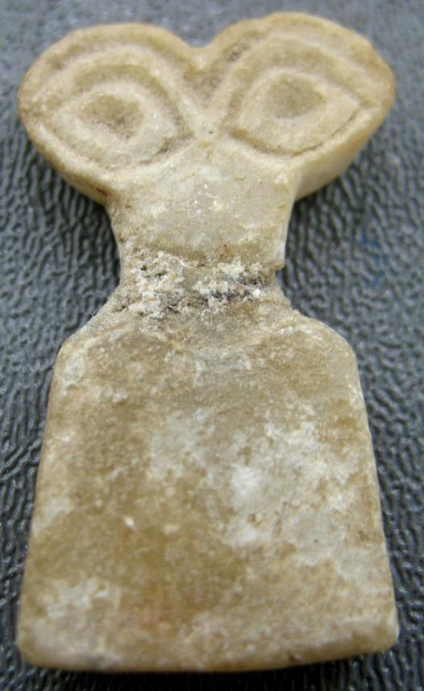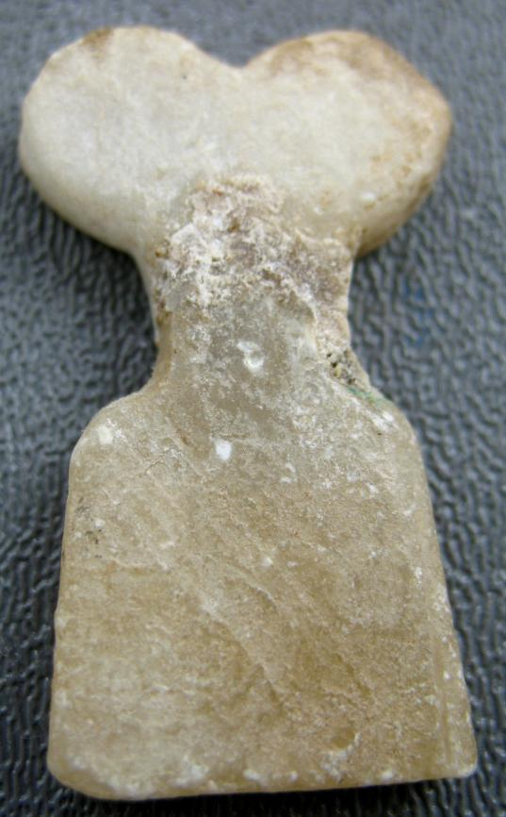

Fig. 2. Eye idol, 3500–3100 b.c.; middle–late Uruk period  
Excavated at Tell Brak, northeastern Syria  
Alabaster (gypsum) repair at the neck level, which is common.

H. 1.5". (3.8 cm)  
 Atlantika Collection.

This type of figurine, made of stone and having incised eyes, has been excavated at Tell Brak, where thousands were found in a building now called the Eye Temple. Many are incised with multiple sets of eyes, others with jewelry, and still others with representations of "children"—smaller eyes and body carved on the body of the larger idol. The idols are thought to be offerings—wide eyes demonstrate attentiveness to the gods in much Mesopotamian art.

This piece was originally purchased from the well-known antiquities dealer, Artemission.com (Atticart Ltd.) based in South Kensington, London, U.K. "According to Artemision, which is one of the greatest authorities on antiquities on the Near East, this relic is from Tell Brak and dates to circa 3,000 B.C.E. This is an authentic artifact.

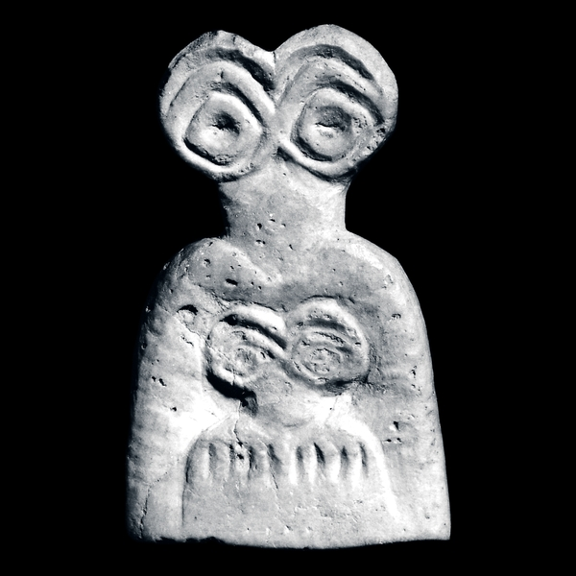

Fig. 3. Tell Brak, http://www.britishmuseum.org/images/com1603b_l.jpg

.

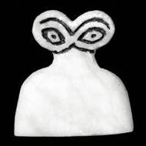

Fig. 4. Tell Brak, excavated by Max Mallowan British Museum

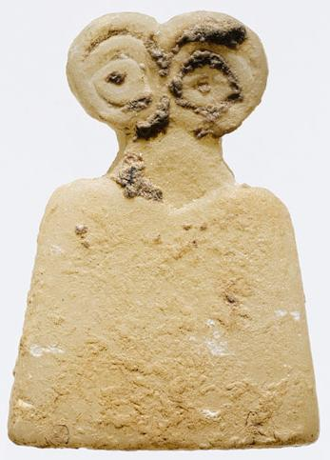

Fig. 5. Eye idol, 3500–3100 BCE; middle–late Uruk period  
Excavated at Tell Brak, northeastern Syria  
 H. 1 3/8 in. (3.5 cm)  
Joint Expedition of the British Museum and the British School of Archaeology in Iraq  
Gift of The Colt Archaeological Institute Inc., 1988 (1988.323.8)

Metropolitan Museum of Art

This type of figurine, made of stone and having incised eyes, has been excavated at Tell Brak, where thousands were found in a building now called the Eye Temple. Many are incised with multiple sets of eyes, others with jewelry, and still others with representations of "children"—smaller eyes and body carved on the body of the larger idol. The idols are thought to be offerings—wide eyes demonstrate attentiveness to the gods in much Mesopotamian art.

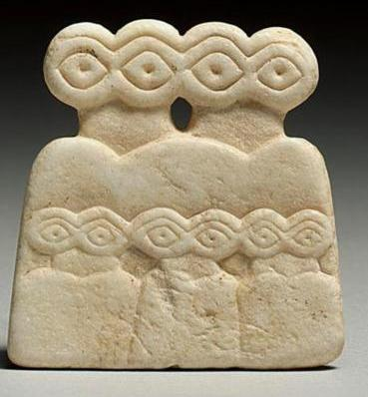

Fig. 6. A Calcite Eye Idol, From Tell Brak, [www.baghdadmuseum.org](http://www.baghdadmuseum.org/wmcd_index.htm).

A CALCITE IDOL, TELL BRAK, CIRCA LATE 4TH MILLENNIUM B.C. 1 7/8 in. 4.7 cm.

of flat highly stylized form composed of two robed figures side by side, three diminutive figures carved in relief below. SNY1290364

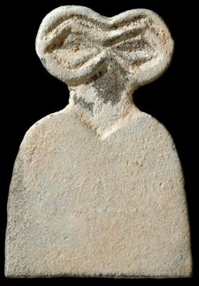

Fig. 7.

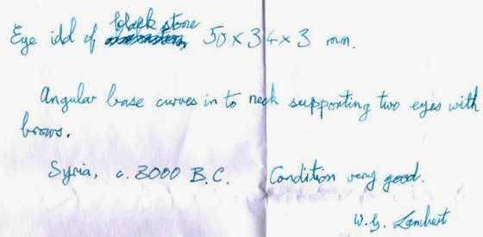

From the Louvre

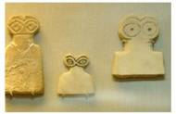

Fig. 8.

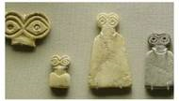

Fig. 9

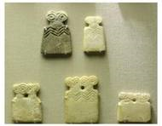

Fig. 10.

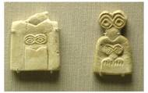

Fig. 11.

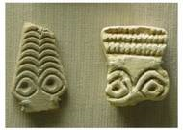

Fig. 12.

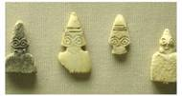

Fig. 13.

From excavations at Hamoukar

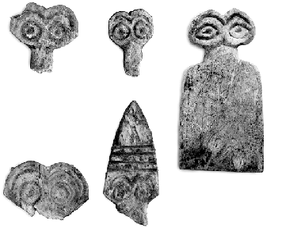

Fig.14.

From Tell brak

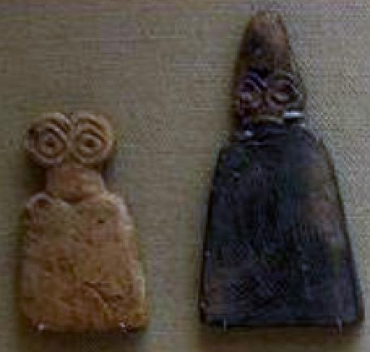

Fig.15.

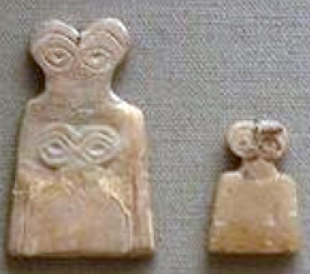

Fig. 16.

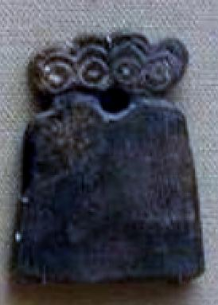

Fig.17.

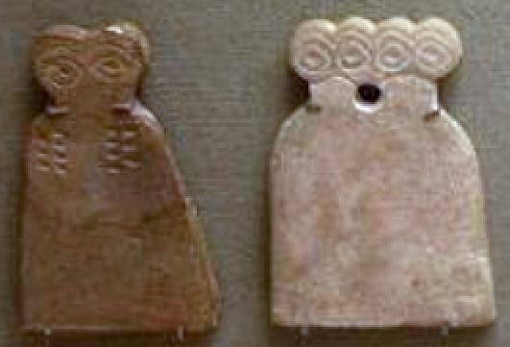

Fig.18.

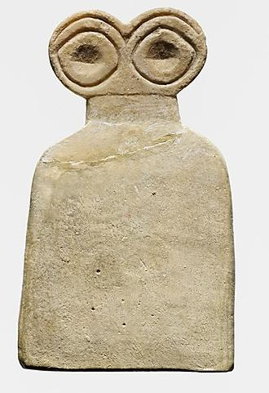

## Fig. 19. Eye idol

Period:

Middle Uruk

Date:

ca. 3700–3500 B.C.

Geography:

Syria, Tell Brak

Medium:

Gypsum alabaster

Dimensions:

3 5/8 in. (9.3 cm)

Classification:

Stone

Credit Line:

Gift of The Institute of Archaeology, The University of London, 1951. MMA

Accession Number:

51.59.1

1937-38, excavated by Max Mallowan, on behalf of the British School of Archaeology in Iraq; ceded in the division of finds to the British School of Archaeology in Iraq; acquired by the Museum in 1951, gift of the Institute of Archaeology, University College London

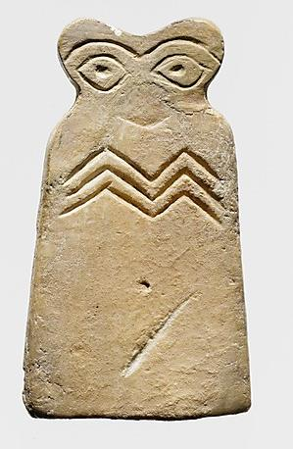

Fig. 20. Eye idol

Period: Middle Uruk

Date: ca. 3700–3500 B.C.

Geography: Syria, Tell Brak

Medium: Gypsum alabaster

Dimensions: 3 in. (7.6 cm)

Classification: Stone

Credit Line: Gift of The Institute of Archaeology, The University of London, 1951

MMA Accession Number:

51.59.7

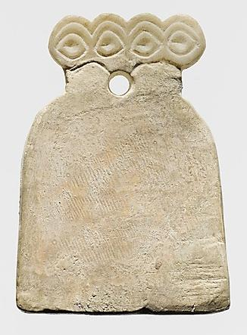

## Fig. 20a Eye idol

Period: Middle Uruk

Date: ca. 3700–3500 B.C.

Geography: Syria, Tell Brak

Medium: Gypsum alabaster

Dimensions: 2 7/8 x 2 x 1/4 in. (7.3 x 5.2 x 0.7 cm)

Classification: Stone

Credit Line: Gift of The Institute of Archaeology, The University of London, 1951

Accession Number: 51.59.8

1937-38, excavated by Max Mallowan, on behalf of the British School of Archaeology in Iraq; ceded in the division of finds to the British School of Archaeology in Iraq; acquired by the Museum in 1951, gift of the Institute of Archaeology, University College London

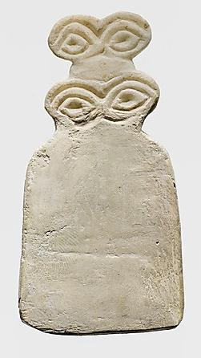

Fig. 20b

## Eye idol

Period: Middle Uruk

Date: ca. 3700–3500 B.C.

Geography: Syria, Tell Brak

Medium: Gypsum alabaster

Dimensions: 3 7/8 in. (9.8 cm)

Classification: Stone

Credit Line: Gift of The Institute of Archaeology, The University of London, 1951

Accession Number: 51.59.9

1937-38, excavated by Max Mallowan, on behalf of the British School of Archaeology in Iraq; ceded in the division of finds to the British School of Archaeology in Iraq; acquired by the Museum in 1951, gift of the Institute of Archaeology, University College London

From the Fitzwilliam Museum, Cambridge, England

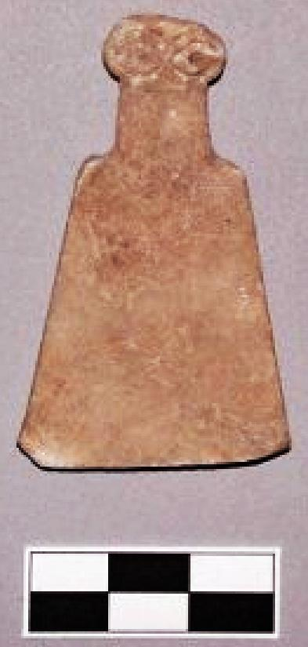

Fig.21.

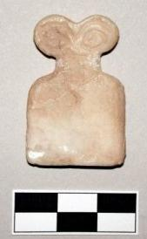

Fig.22.

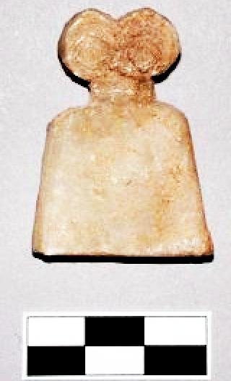

Fig.23

From Département des Monnaies, Médailles et Antiques de la Bibliothèque nationale de France 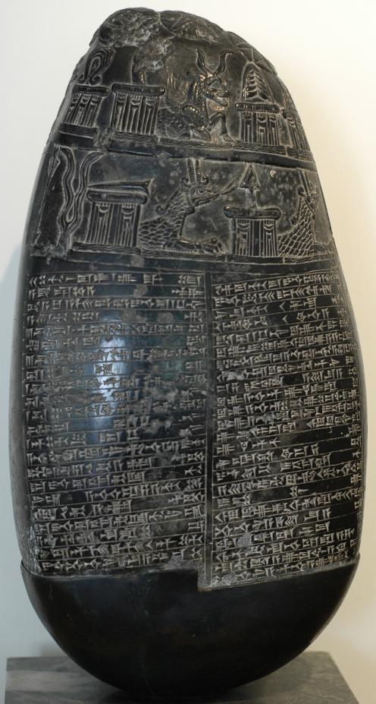

Fig. 24a Kudurru , H. 45 cm (17 ½ in.), *Département des Monnaies, Médailles et Antiques de la Bibliothèque nationale de France,* Chabouillet no. 702

Babylonian *kudurru* of the Kassite Period, known as the "Michaux Stone". The stele bears an inscription (a property charter) in Akkadian script. Black serpentine, early 11th century BC, found near Baghdad in 1784 by the French botanist Michaux, hence the name.

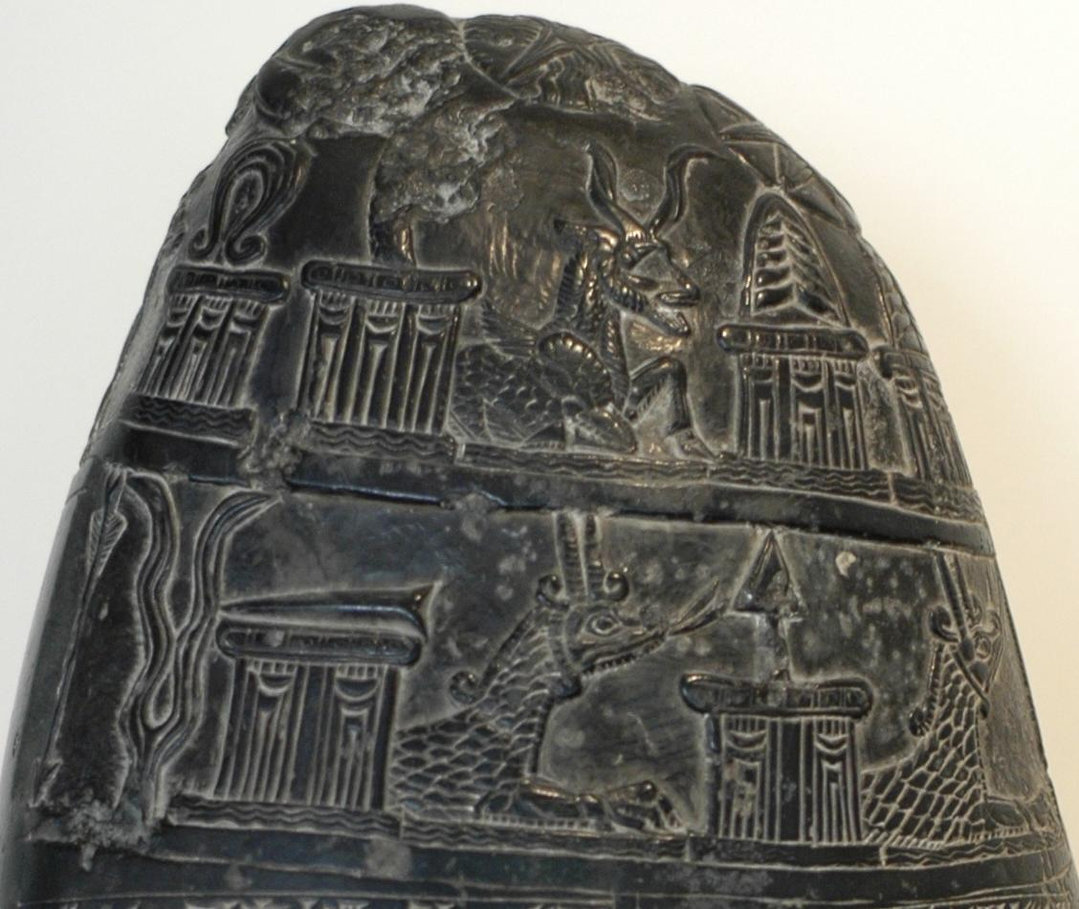

Kudurru detail

Fig.24b

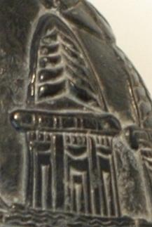

Horned altar, detail.

Fig. 24c

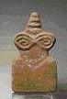

Fig.25.

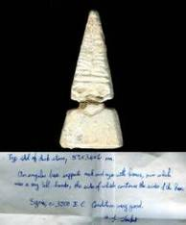

Fig.26

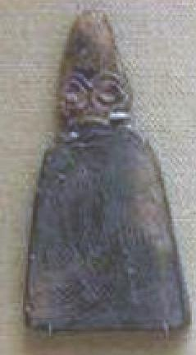

from Tell Brak

Fig. 27

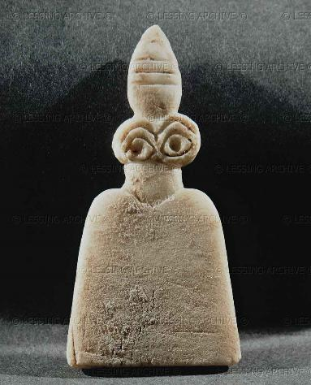

Fig. 27. Idol with huge eyes. Alabaster statuette (3500-3300 BCE) from the Temple of the Eyes, Tell Braq Height 8.1 cm National Museum, Aleppo, Syria

# Münzenhandlung G. Hirsch Nachfolger   |   Auction 286   |   5 - 6 February 2013 Online bidding closed

|  |  |
| --- | --- |
| [<< Previous lot](http://www.sixbid.com/browse.html?auction=616&category=13733&lot=621042) | [Next lot >>](http://www.sixbid.com/browse.html?auction=616&category=13733&lot=621044) |
|  | |
| Fig. 28   |  |  | | --- | --- | | **Lot:** 1164   |   **Estimate:** -   |   **Starting price:** 120 EUR | **Price realized:** 340 EUR |   Augenidol aus Marmor. Augen angegeben. Tell-Brak-Typus, 2. Hälfte 4. Jt. v. Chr. H. 3,0 cm. Restauriert. Aus alter französischer Sammlung. | |

# Münzenhandlung G. Hirsch Nachfolger   |   Auction 286   |   5 - 6 February 2013 Online bidding closed

|  |  |
| --- | --- |
| [<< Previous lot](http://www.sixbid.com/browse.html?auction=616&category=13733&lot=621041) | [Next lot >>](http://www.sixbid.com/browse.html?auction=616&category=13733&lot=621043) |
|  | |
| Fig. 29   |  |  | | --- | --- | | **Lot:** 1163   |   **Estimate:** -   |   **Starting price:** 240 EUR | **Price realized:** 600 EUR |   Augenidol aus Marmor. Doppeltes Augenpaar angegeben. Tell-Brak-Typus, 2. Hälfte 4. Jt. v. Chr. H. 3,8 cm. Intakt. Aus alter französischer Sammlung. | |

# Münzenhandlung G. Hirsch Nachfolger   |   Auction 286   |   5 - 6 February 2013 Online bidding closed

|  |  |
| --- | --- |
| [<< Previous lot](http://www.sixbid.com/browse.html?auction=616&category=13733&lot=621040) | [Next lot >>](http://www.sixbid.com/browse.html?auction=616&category=13733&lot=621042) |
|  | |
| Fig. 30   |  |  | | --- | --- | | **Lot:** 1162   |   **Estimate:** -   |   **Starting price:** 140 EUR | **Price realized:** 140 EUR |   Augenidol aus Marmor. Augen angegeben. Tell-Brak-Typus, 2. Hälfte 4. Jt. v. Chr. H. 4,3 cm. Restauriert. Aus US-amerikanischer Sammlung. | |

# Münzenhandlung G. Hirsch Nachfolger   |   Auction 286   |   5 - 6 February 2013 Online bidding closed

|  |  |
| --- | --- |
| [<< Previous lot](http://www.sixbid.com/browse.html?auction=616&category=13733&lot=621039) | [Next lot >>](http://www.sixbid.com/browse.html?auction=616&category=13733&lot=621041) |
|  | |
| Fig. 31   |  |  | | --- | --- | | **Lot:** 1161   |   **Estimate:** -   |   **Starting price:** 120 EUR | **Price realized:** 280 EUR | | |

# Münzenhandlung G. Hirsch Nachfolger   |   Auction 286   |   5 - 6 February 2013 Online bidding closed

|  |  |
| --- | --- |
| [<< Previous lot](http://www.sixbid.com/browse.html?auction=616&category=13733&lot=621038) | [Next lot >>](http://www.sixbid.com/browse.html?auction=616&category=13733&lot=621040) |
|  | |
| Fig. 32   |  |  | | --- | --- | | **Lot:** 1160   |   **Estimate:** -   |   **Starting price:** 160 EUR | **Price realized:** 575 EUR |   Augenidol mit Binnenzeichnung. Kalkstein. Augen angegeben. Tell-Brak-Typus, 2. Hälfte 4. Jt. v. Chr. H. 5,1 cm. Restauriert. Aus englischer Sammlung. | |

# Münzenhandlung G. Hirsch Nachfolger   |   Auction 286   |   5 - 6 February 2013 Online bidding closed

|  |  |
| --- | --- |
| [<< Previous lot](http://www.sixbid.com/browse.html?auction=616&category=13733&lot=621037) | [Next lot >>](http://www.sixbid.com/browse.html?auction=616&category=13733&lot=621039) |
|  | |
| Fig. 33   |  |  | | --- | --- | | **Lot:** 1159   |   **Estimate:** -   |   **Starting price:** 120 EUR | **Price realized:** 300 EUR |   Augenidol aus Marmor. Augen angegeben. Tell-Brak-Typus, 2. Hälfte 4. Jt. v. Chr. H. 5,5 cm. Intakt.  Ex Hirsch 222, 2002, Los Nr. 1068. | |

Catalogue: Eye-like Figurine, Type Two

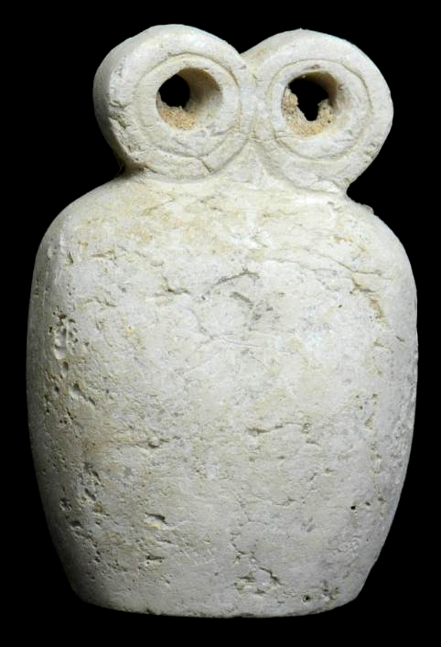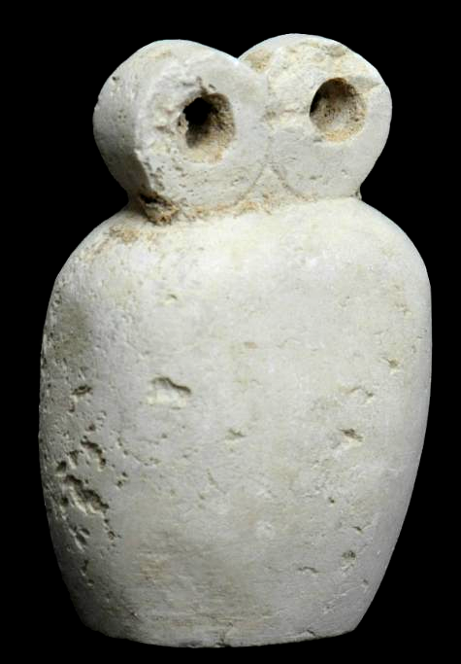

Fig.28. SYRIAN Calcite SPECTACLE IDOL

TELL BRAK, CIRCA 4TH MILLENNIUM BCE

Dimensions: **3 3/8 in. high (8.3 cm.).**  
Calcite, with bell-shaped body surmounted by two circular perforated 'eyes.'  
Provenance: **Ex. Early European Private Collection, now Atlantika**  
Certificate of Authenticity.

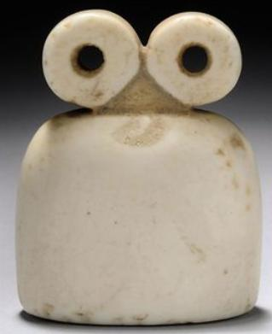

Fig. 29. A SYRIAN WHITE STONE SPECTACLE IDOL   
TELL BRAK, CIRCA 4TH MILLENNIUM B.C.   
With bell-shaped body surmounted by two circular perforated 'eyes'   
2 1/8 in. (5.3 cm.) high

Provenance: Gawain McKinley collection, acquired prior to 1996.

Price Realized: £8,125 ($12,927)

Christies' London, South Kensington

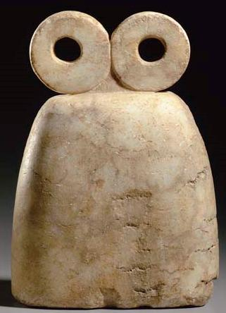

Fig. 30. A SYRIAN MARBLE SPECTACLE IDOL   
CIRCA 4TH MILLENNIUM B.C.   
The tall, bell-shaped body with a flat base, tapering toward the top and surmounted by two round perforated "eyes"  
10¾ in. (27.3 cm.) tall

Provenance: German Private Collection, 1980s.

Price Realized  [Christies'.](http://www.christies.com/MyChristies/my_settings_currency.aspx)

$62,400

Sales totals are hammer price plus buyer’s premium and do not reflect costs, financing fees or application of buyer’s or seller’s credits.

Estimate

$12,000 - $18,000

Sale Information

Sale [1846](http://www.christies.com/LotFinder/searchresults.aspx?action=search&intSaleID=21347)   
[Antiquities](http://www.christies.com/LotFinder/searchresults.aspx?action=search&intSaleID=21347)   
8 June 2007   
Christies' New York, Rockefeller Plaza

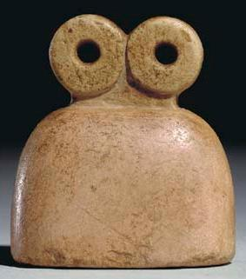

Fig. 31. A SYRIAN PINK STONE SPECTACLE IDOL   
TELL BRAK REGION  
CIRCA 4TH MILLENNIUM B.C.  
The bell-shaped body with a short neck, rectangular in section, surmounted by two circular perforated "eyes"  
2 in. (5.1 cm.) high

Provenance

Dr. Elie Borowski.  
French Private Collection, 1970s.

Price Realized [(Set Currency)](http://www.christies.com/MyChristies/my_settings_currency.aspx)

$3,824

Sales totals are hammer price plus buyer’s premium and do not reflect costs, financing fees or application of buyer’s or seller’s credits.

Estimate

$4,000 - $6,000

Sale Information

Sale [1446](http://www.christies.com/LotFinder/searchresults.aspx?action=search&intSaleID=18930)   
  
10 December 2004   
Christies' New York, Rockefeller Plaza

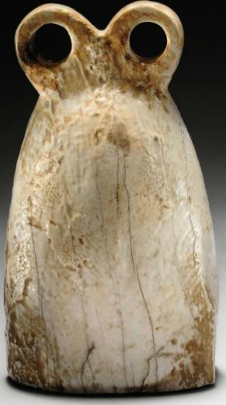

Fig. 32.A SYRIAN GYPSUM SPECTACLE IDOL   
TELL BRAK, CIRCA 4TH MILLENNIUM B.C.   
The bell-shaped body oval in section, surmounted by two circular perforated 'eyes'  
4½ in. (11.4 cm.) high

Provenance

Collection of Z. Wolloch, New York, 1960s.  
With Fortuna Fine Arts, New York, 2007 (Venerable Traditions, Works of Art from the Ancient World, no. 2).

Price Realized [(Set Currency)](http://www.christies.com/MyChristies/my_settings_currency.aspx)

£6,875

($10,938)

Sales totals are hammer price plus buyer’s premium and do not reflect costs, financing fees or application of buyer’s or seller’s credits.

Estimate

£6,000 - £8,000

($9,552 - $12,736)

Sale Information

Sale [5488](http://www.christies.com/LotFinder/searchresults.aspx?action=search&intSaleID=22908)   
Christies' London, South Kensington

7 October 2010   
 [Contact the Department](http://www.christies.com/lotfinder/ancient-art-antiquities/a-syrian-gypsum-spectacle-idol-tell-brak-5358332-details.aspx)

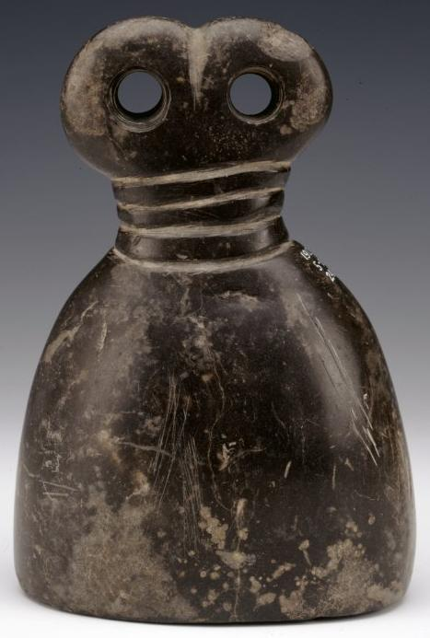

Fig. 33. AN175806001

© The Trustees of the British Museum

Department: Middle East

Registration number: 1912,0511.240

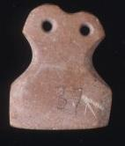

Fig. 34. AN235470001

© The Trustees of the British Museum

Department: Middle East

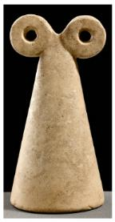

Fig. 35. from the Tomkins collection

# Münzenhandlung G. Hirsch Nachfolger   |   Auction 286   |   5 - 6 February 2013 Online bidding closed

|  |  |
| --- | --- |
| [<< Previous lot](http://www.sixbid.com/browse.html?auction=616&category=13733&lot=621043) | [Next lot >>](http://www.sixbid.com/browse.html?auction=616&category=13733&lot=621045) |
|  | |
| |  |  | | --- | --- | | **Lot:** 1165   |   **Estimate:** -   |   **Starting price:** 560 EUR | **Price realized:** 2'000 EUR | | |

# Münzenhandlung G. Hirsch Nachfolger   |   Auction 286   |   5 - 6 February 2013 Online bidding closed

|  |  |
| --- | --- |
| [<< Previous lot](http://www.sixbid.com/browse.html?auction=616&category=13733&lot=621036) | [Next lot >>](http://www.sixbid.com/browse.html?auction=616&category=13733&lot=621038) |
|  | |
| |  |  | | --- | --- | | **Lot:** 1158   |   **Estimate:** -   |   **Starting price:** 240 EUR | **Price realized:** 800 EUR |   Augenidol aus Marmor. Tell-Brak-Typus, 2. Hälfte 4. Jt. v. Chr. H. 4,7 cm. Restauriert. Aus alter französischer Sammlung. | |

# Münzenhandlung G. Hirsch Nachfolger   |   Auction 286   |   5 - 6 February 2013 Online bidding closed

|  |  |
| --- | --- |
| [<< Previous lot](http://www.sixbid.com/browse.html?auction=616&category=13733&lot=621035) | [Next lot >>](http://www.sixbid.com/browse.html?auction=616&category=13733&lot=621037) |
|  | |
| |  |  | | --- | --- | | **Lot:** 1157   |   **Estimate:** -   |   **Starting price:** 320 EUR | **Price realized:** 1'600 EUR |   Augenidol aus schwarzem Stein. Tell-Brak-Typus, 2. Hälfte 4. Jt. v. Chr. H. 5,8 cm. Intakt. Aus alter französischer Sammlung. | |

# Münzenhandlung G. Hirsch Nachfolger   |   Auction 286   |   5 - 6 February 2013 Online bidding closed

|  |  |
| --- | --- |
| [<< Previous lot](http://www.sixbid.com/browse.html?auction=616&category=13733&lot=621034) | [Next lot >>](http://www.sixbid.com/browse.html?auction=616&category=13733&lot=621036) |
|  | |
| |  |  | | --- | --- | | **Lot:** 1156   |   **Estimate:** -   |   **Starting price:** 160 EUR | **Price realized:** 180 EUR |   Augenidol aus grauem Stein. Tell-Brak-Typus, 2. Hälfte 4. Jt. v. Chr. H. 8,1 cm. Restauriert. Aus alter französischer Sammlung. | |

# Münzenhandlung G. Hirsch Nachfolger   |   Auction 286   |   5 - 6 February 2013 Online bidding closed

|  |  |
| --- | --- |
| [<< Previous lot](http://www.sixbid.com/browse.html?auction=616&category=13733&lot=621033) | [Next lot >>](http://www.sixbid.com/browse.html?auction=616&category=13733&lot=621035) |
|  | |
| |  |  | | --- | --- | | **Lot:** 1155   |   **Estimate:** -   |   **Starting price:** 520 EUR | **Price realized:** 2'100 EUR |   Augenidol aus Kalkstein. Beidseitig Rautenmuster im Relief. Tell-Brak-Typus, 2. Hälfte 4. Jt. v. Chr. H. 12,3 cm. Intakt. Aus englischer Sammlung. | |

# Münzenhandlung G. Hirsch Nachfolger   |   Auction 286   |   5 - 6 February 2013 Online bidding closed

|  |  |
| --- | --- |
| [<< Previous lot](http://www.sixbid.com/browse.html?auction=616&category=13733&lot=621032) | [Next lot >>](http://www.sixbid.com/browse.html?auction=616&category=13733&lot=621034) |
|  | |
| |  |  | | --- | --- | | **Lot:** 1154   |   **Estimate:** -   |   **Starting price:** 1'000 EUR | **Price realized:** 2'100 EUR |   Augenidol aus Marmor. Beidseitig Binnenzeichnung. Tell-Brak-Typus, 2. Hälfte 4. Jt. v. Chr. H. 13,9 cm. Randlich leicht bestoßen, sonst intakt. Aus bayerischem Besitz. | |

# Münzenhandlung G. Hirsch Nachfolger   |   Auction 286   |   5 - 6 February 2013 Online bidding closed

|  |  |
| --- | --- |
| [<< Previous lot](http://www.sixbid.com/browse.html?auction=616&category=13733&lot=621031) | [Next lot >>](http://www.sixbid.com/browse.html?auction=616&category=13733&lot=621033) |
|  | |
| |  |  | | --- | --- | | **Lot:** 1153   |   **Estimate:** -   |   **Starting price:** 560 EUR | **Price realized:** 560 EUR |   Großes Augenidol aus rötlichem Ton. Tell-Brak-Typus, 2. Hälfte 4. Jt. v. Chr. H. ca. 23 cm. cm. Restauriert, Fuß fehlt. Aus alter französischer Sammlung. | |

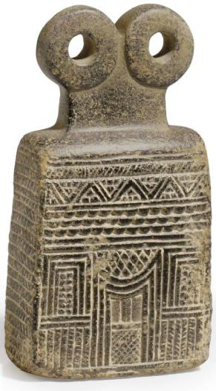

A MESOPOTAMIAN STEATITE SPECTACLE IDOL   
SYRIA, CIRCA 3000-2500 B.C.   
The rectangular architectonic base with curving shoulders, sculpted on all four sides with a tiered facade, composed of several friezes including hatching, beading, zigzag, and crosshatching, centered by a doorway on each long side with a concave upper surface, the disk "eyes" above the waisted rectangular neck  
5 7/8 in. (14.9 cm.) high

Provenance

with Elie Borowski, Basel, 1965.

Sale Information, Sale [2450](http://www.christies.com/LotFinder/searchresults.aspx?action=search&intSaleID=23019)  Price Realized $40,000   
9 June 2011   
Christie's New York, Rockefeller Plaza

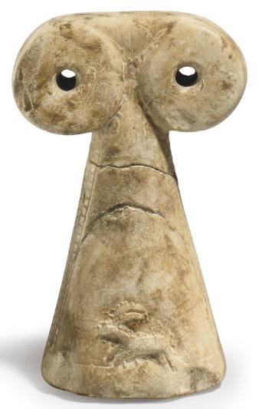

A MESOPOTAMIAN STONE SPECTACLE IDOL   
SYRIA, CIRCA 3000 B.C.   
The tall, conical body on a flat circular base, tapering toward the top and surmounted by two perforated disk "eyes," an ibex and a panther in relief along the body, flanked by vertical hatched bands along the sides  
5 7/8 in. (14.8 cm.) high

## Provenance

Irvin Gilbert Kipsby, New York, 1981.

Sale [2450](http://www.christies.com/LotFinder/searchresults.aspx?action=search&intSaleID=23019)   
 9 June 2011   
Christie's New York, Rockefeller Plaza

Price Realized $10,625

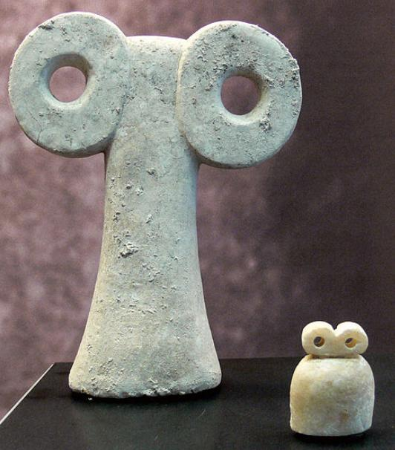

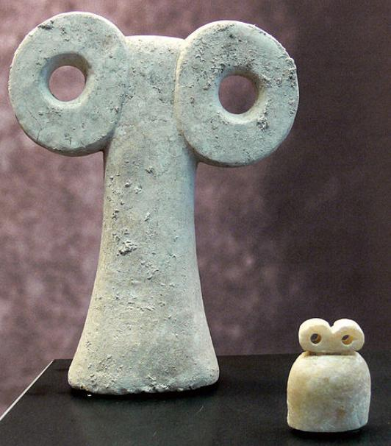

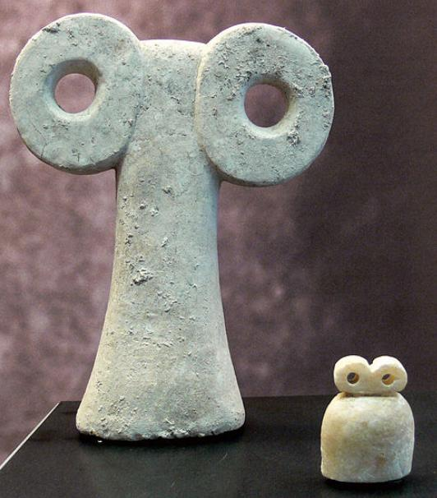

Schaffhausen, Museum zu Allerheiligen, Sammlung Ebnöther, (Abteilung "Idole")  
Zwei Augenidole, links: Kalkstein (Höhe 19,3 cm), rechts: Alabaster (Höhe: 4,6 cm), aus Syrien, 2. Hälfte des 4. Jahrtausend vor Christus; genaue Provenienz nicht angegeben; solche Idole wurden lt. Katalog gefunden in Tepe Gaura und im Augentempel von Tell Brak (Katalog 1999, S. 22)